EXPT NO: 8 | TRAIN A SIMPLE AUTOENCODER FOR DIMENSIONALITY REDUCTION AND FEATURE LEARNING
DATE: 29.10.2026

PRE-LAB QUESTIONS (PROVIDE BRIEF ANSWERS TO THE FOLLOWING QUESTIONS)

- What is an autoencoder?
An autoencoder is a neural network that learns to compress input data and reconstruct the original data.

- What are the roles of the encoder and decoder in an autoencoder?
Encoder: Compresses the input into a smaller representation.
Decoder: Reconstructs the original input from the compressed representation.

- What is dimensionality reduction?
Dimensionality reduction is the process of reducing the number of features in data while retaining important information.

- What is meant by latent representation or latent space?
Latent representation is a compressed form of input data that stores its important features.

- Why is reconstruction loss used when training an autoencoder?
Reconstruction loss measures the difference between the original input and reconstructed output. The model tries to minimize this loss.

AIM
To implement and train a simple autoencoder using a dataset such as MNIST, learn a lower-dimensional representation of the input data, and evaluate the model by reconstructing the input samples and visualizing their latent representations.

SOFTWARE REQUIREMENTS
- Python
- TensorFlow / Keras
- Google Colab or Jupyter Notebook
- GitHub
- NumPy
- Matplotlib
- Pandas (optional)

OBJECTIVES
Students will be able to:
- Understand the architecture and working of autoencoders.
- Differentiate between the encoder, latent representation, and decoder.
- Prepare and preprocess a dataset for autoencoder training.
- Build an autoencoder using appropriate neural network layers.
- Train the model using reconstruction loss.
- Perform dimensionality reduction and extract latent features.
- Visualize original and reconstructed samples.
- Evaluate reconstruction performance using loss values and visual inspection.

PROCEDURE
PART A: DATASET PREPARATION AND PREPROCESSING
Perform the following tasks:
- Load the MNIST handwritten digit dataset using TensorFlow/Keras.
- Explore the dataset and check the number of training and testing images and their dimensions.
- Display sample images from the dataset.
- Convert pixel values to floating-point values and normalize them to the range [0, 1].
- Flatten each 28 × 28 image into a 784-dimensional input vector for a basic dense autoencoder.
- Prepare training and testing data. Use the input images as both input and target output because the autoencoder learns to reconstruct its input.
CODE:
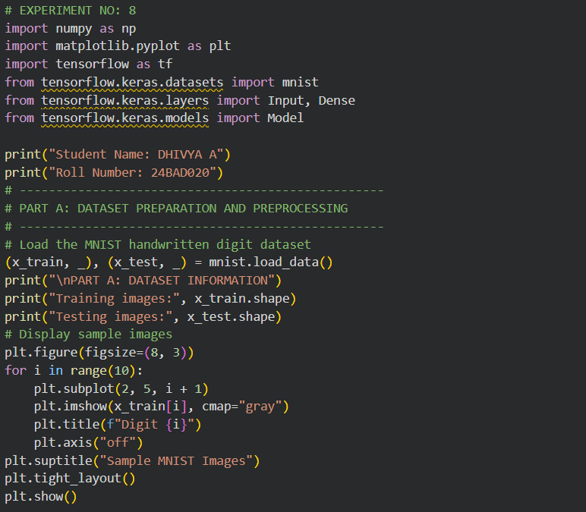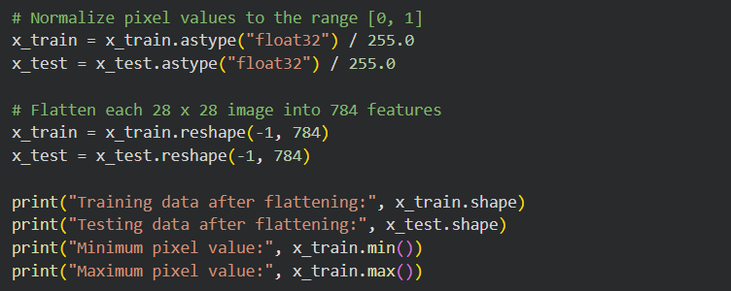

OUTPUT:
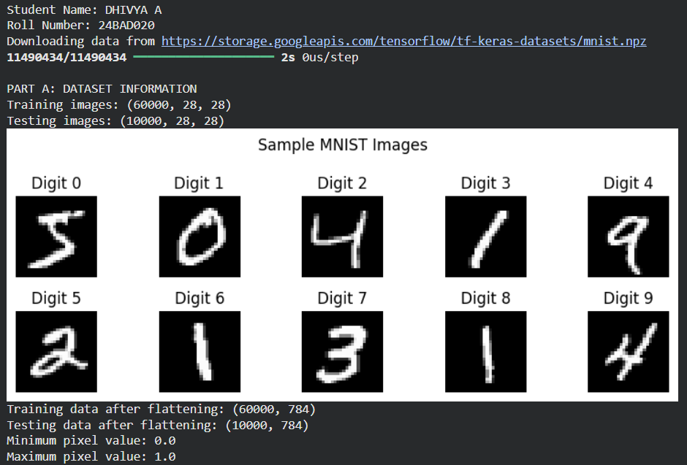

PART B: IMPLEMENTING THE ENCODER AND DECODER
Perform the following tasks:
- Define the input layer with 784 features.
- Build the encoder using one or more Dense layers to map the input to a smaller latent dimension, such as 32 features.
- Build the decoder using Dense layers to map the latent representation back to 784 output values.
- Use suitable activation functions, such as ReLU for hidden layers and Sigmoid for the final layer.
- Combine the encoder and decoder into a single autoencoder model.
- Display the encoder, decoder, and autoencoder model summaries.

CODE:
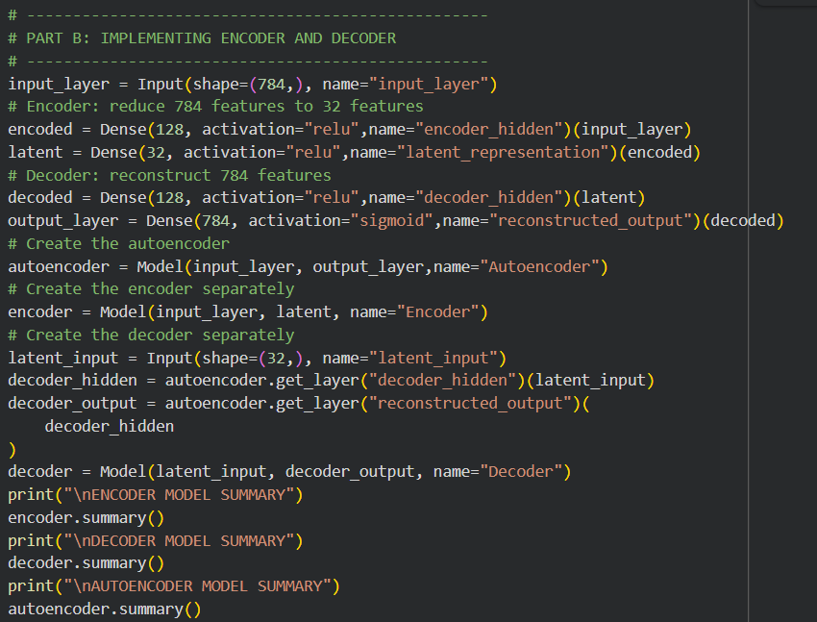

OUTPUT:
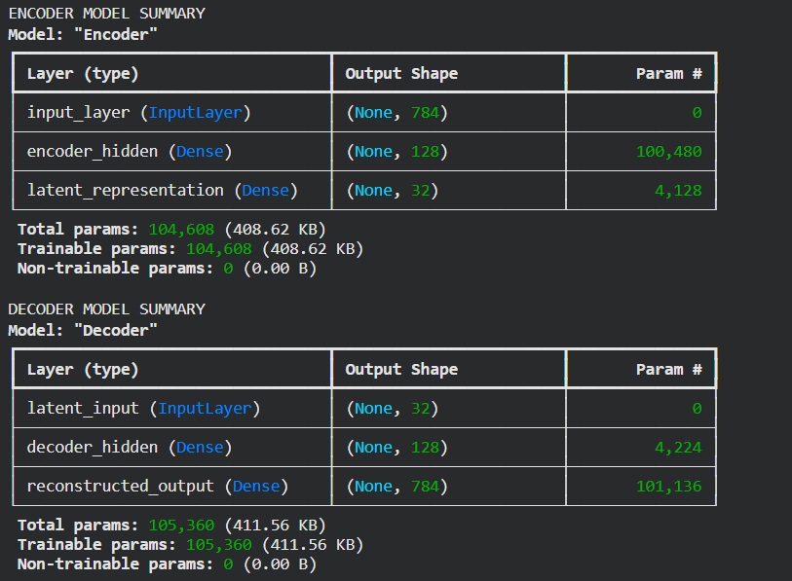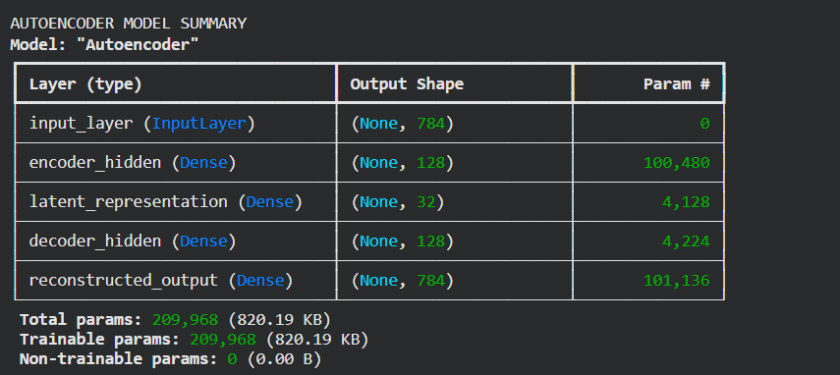

PART C: COMPILING AND TRAINING THE AUTOENCODER
Perform the following tasks:
- Compile the autoencoder using an optimizer such as Adam.
- Select an appropriate reconstruction loss, such as binary cross-entropy or mean squared error.
- Train the model by supplying the input images as both input data and target data.
- Use a suitable batch size and number of epochs. For example, use a batch size of 256 and 10 epochs.
- Validate the model using the test dataset or a validation split.
- Record training and validation loss for each epoch.
- Plot the training and validation loss curves to observe the reconstruction performance.

CODE:
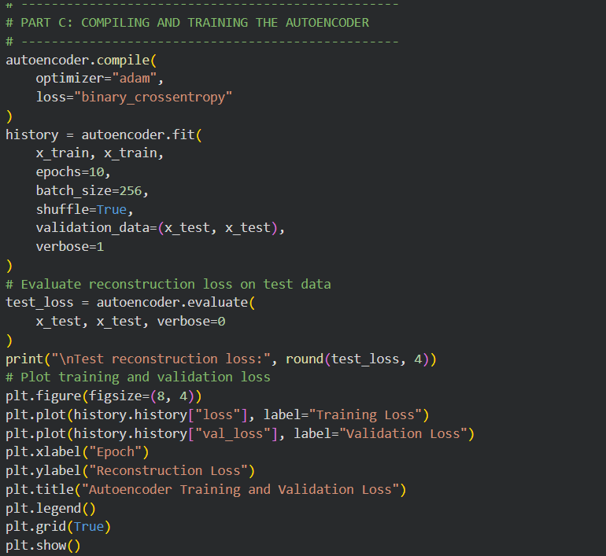

OUTPUT:
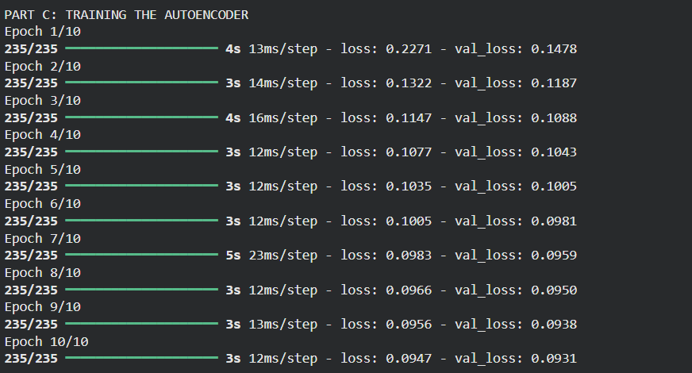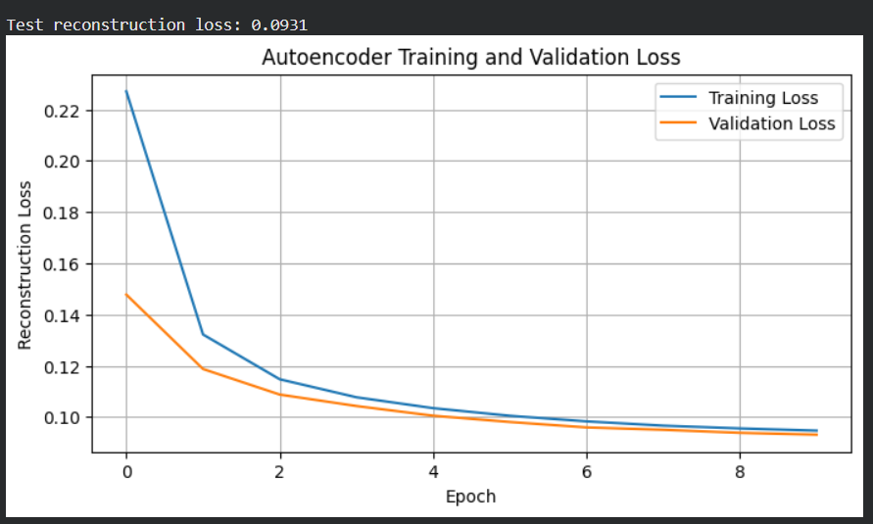

PART D: DIMENSIONALITY REDUCTION, FEATURE LEARNING AND RECONSTRUCTION
Perform the following tasks:
- Use the trained encoder to convert test images into lower-dimensional latent feature vectors.
- Display the original input dimension (784) and latent dimension (for example, 32).
- Pass the latent vectors through the decoder to reconstruct the images.
- Display original images and their corresponding reconstructed images side by side.
- Compare the original and reconstructed images and comment on the information retained or lost.
- Optionally, use PCA or t-SNE to visualize latent features in two dimensions, if covered in the course.
- Save the trained model or reconstructed images if required.

CODE:
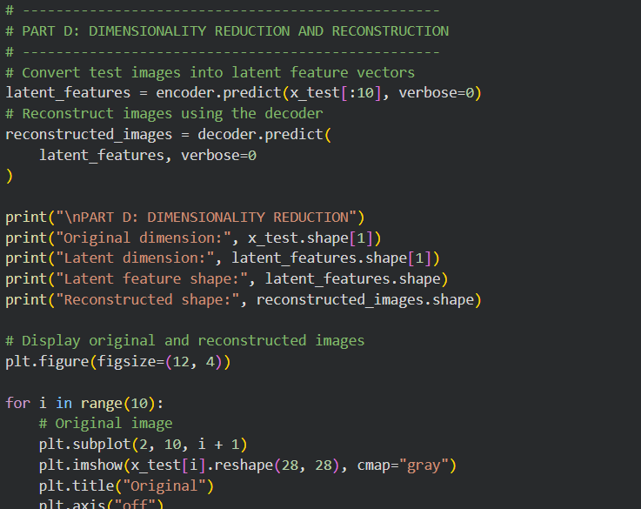
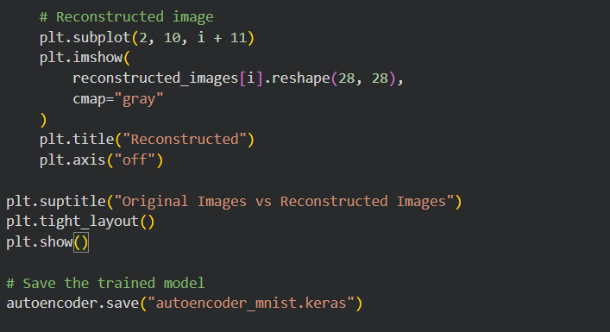

OUTPUT:
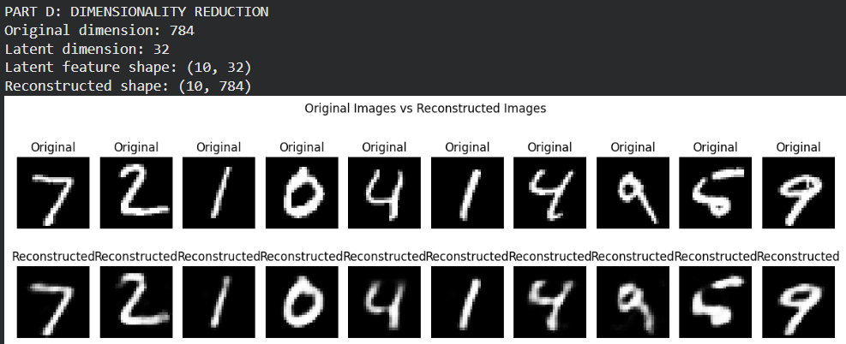

EXPECTED OUTCOME
Students will understand the architecture and working of a simple autoencoder and the roles of its encoder, latent representation, and decoder. They will learn to preprocess data, train the model using reconstruction loss, reduce input dimensionality, and extract compact latent features. They will evaluate the autoencoder by examining training and validation loss and comparing original images with reconstructed images.

POST-LAB QUESTIONS (PROVIDE BRIEF ANSWERS TO THE FOLLOWING QUESTIONS)

- What is the main purpose of an autoencoder?
To learn a compressed representation of data and reconstruct the original input.

- How do the encoder and decoder differ?
The encoder compresses the input, while the decoder reconstructs the input from the compressed representation.

- What is a latent representation?
It is a compact representation containing important features of the original input.

- How does an autoencoder perform dimensionality reduction?
It maps high-dimensional input data into a smaller latent space using the encoder.

- Why are the input images also used as target outputs during training?
Because an autoencoder learns to reconstruct its own input rather than predict a separate label.

- What does reconstruction loss measure?
It measures the difference between the original data and the reconstructed data.

- What may happen if the latent dimension is too small?
Important information may be lost, resulting in poor reconstruction quality.

- Mention one real-world application of autoencoders.
Image denoising, where an autoencoder removes noise from images.

SUGGESTIONS FOR DATASETS
- MNIST Handwritten Digits – https://www.tensorflow.org/datasets/catalog/mnist
- Fashion-MNIST – https://www.tensorflow.org/datasets/catalog/fashion_mnist
- CIFAR-10 – https://www.tensorflow.org/datasets/catalog/cifar10 (requires adapting the model for image inputs)

ASSESSMENT
Description | Max Marks | Marks Awarded
Pre Lab Exercise | 5
In Lab Exercise | 10
Post Lab Exercise | 5
Viva | 10
Total | 30
Faculty Signature

